ARC Extension (For Summer Vacation)

- If your ARC is due to the date by September 20th, remember to extend your ARC three weeks before the expired date. Usually it will be extended until the end of September of this year. Then after completing school registration, it has to be extended again for one year.
- If you are supposed to go abroad and return to Taiwan after the expired date, remember to extend it first three or four weeks before going abroad.
- Double check your recent ARC. If there’s some mistake, remember to confirm with the immigration officer to revise it for the ARC new card during the application.

Location: National Immigration Agency Taoyuan County Service Center
Add.: No.106 Hsien-fu Road, Taoyuan City, Taoyuan County
Tel: 03-3314830、03-3310409、03-3318243
Transportation: Taoyuan Bus 1
http://www.immigration.gov.tw/aspcode/index_ch_main.asp

Required documents:
- Original and Copy Student ID Card (Double Check whether it has been stamped for this semester)
- Original and Copy ARC
- Original and Copy Passport
- Two photos within six months (the size as ROC ID Card of Taiwan Residents)
- Staying in Dormitory Certificate or the letter to prove where you stay.
- English Proof of Enrollment (Apply from Registry Office with NT$10)
- Ticket (For those who go abroad and return after the expired date)
- Fee NT$1000
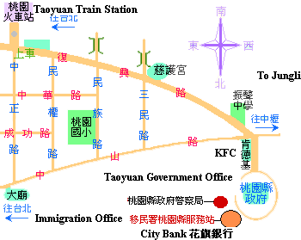
外僑居留證延期流程(暑假)

- 若居留證截止日期在9月20日前，記得截止日三週前辦理延長。
通常移民署會延長至今年9月底。完成註冊後再次辦理延長至隔年。
- 若預計出國且在截止日後才回台灣，請出國前三或四週前辦理延長。
- 確認目前所持居留證之個人資料是否正確。於申辦居留證延期，告知移民署辦事員於新卡上更正。

至『內政部入出國及移民署桃園服務站』辦理居留證。
地址：桃園市縣府路106號
電話：03-3314830、03-3310409、03-3318243
交通：１路公車
http://www.immigration.gov.tw/aspcode/index_ch_main.asp

請帶：1. 學生證正本及影本
2. 二張２吋照片(身分正規格，六個月內)
3. 護照正本及影本
4. 英文在學證明書正本及影本(在註冊組申請，一份10元)
5. 外僑居留證正本及影本
6. 住宿證明或校外住址證明
7. 機票(若出國且在居留証截止日期後返台)
8. 外籍生NT$1,000

